Introduction Lab – Dog Grooming

Class Diagram

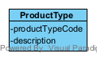

Object Level Sequence Diagram

